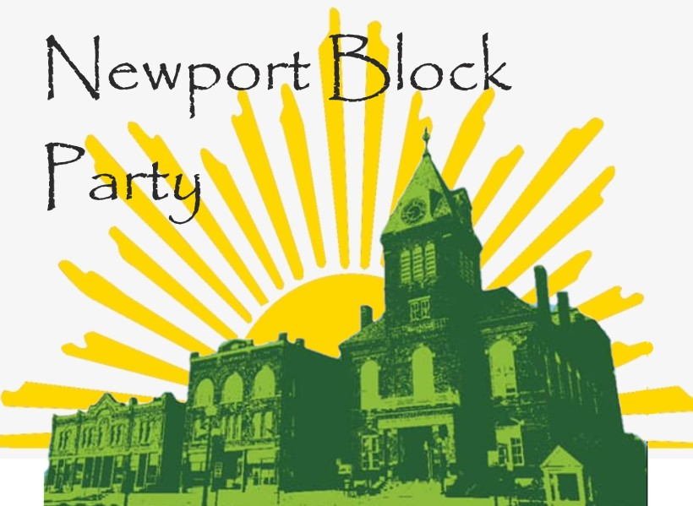

Registration Form
Business Name: ____________________________________
Contact Name: _____________________________________
Contact Phone #: ___________________________________
Contact Email: _____________________________________
Comments: ________________________________________
__________________________________________________
Newport Chamber of Commerce Member? Yes No
If no, cost of a table will be $25.00. Please make checks payable to “Newport Area Chamber of Commerce” with Block Party on the memo line, to 19 Depot Street, Newport, NH 0377
Please fill out this form in its entirety and email it back to asbenson82@gmail.com

Any questions please feel free to contact Amy Benson at 603.306.1672 or asbenson82@gmail.com

